1. What is reactjs
2. Advantage of reactjs
3. What is virtual DOM
4. Which data structure is used to maintain the DOM in reactjs.
5. Life cycle method of Reactjs

Ans 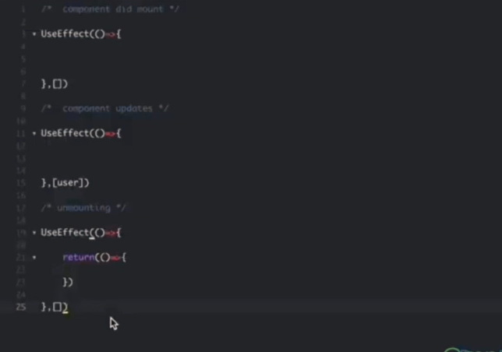

1. Is constructor is mandatory for class in Reactjs
2. What is class component and functional componenent In reactjs
3. Is componentwillmount call every time
4. Whow to achieve life cycle in functional componet
5. How to avoid the infinite rendering in reactjs
6. What is stateless and statefulcomponet in raectjs
7. What is diif betewn state and props
8. What is dump component
9. What is higher order component
10. Which algorithm is used to compare the virtual dom
11. What is hooks
12. How to use useeffect in reactjs
13. How to use usestate hooks
14. What is difference between usecallback and usememo

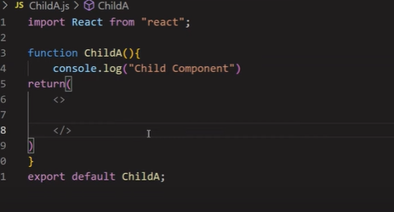

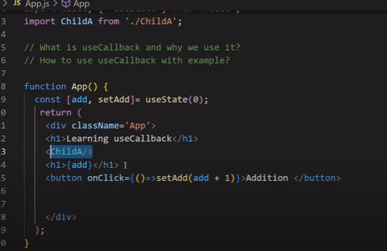

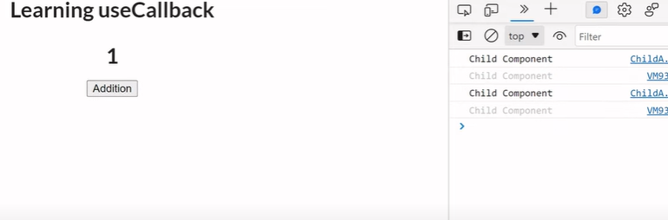

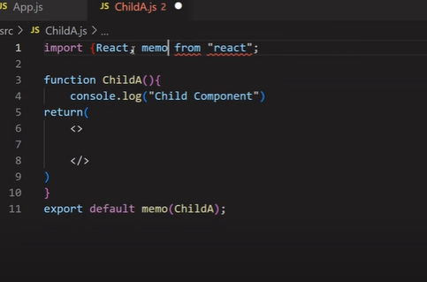

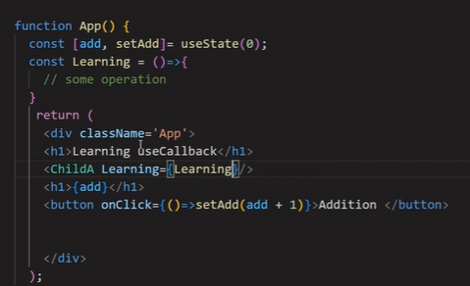

Reactjs concept call referecial equality when our componeet rerender then all function again intize

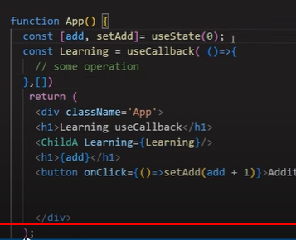

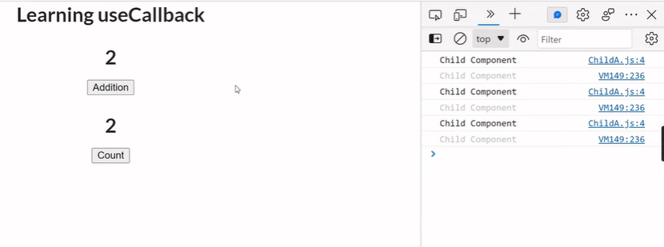

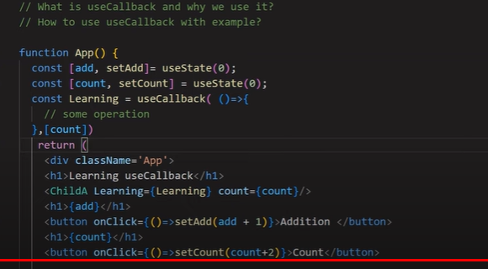

1. Explain usecontext hook

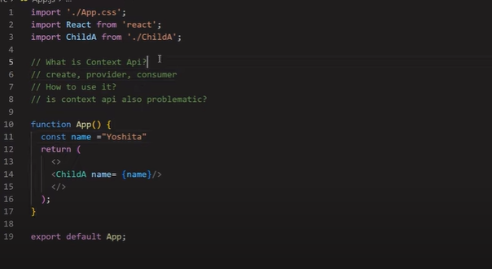

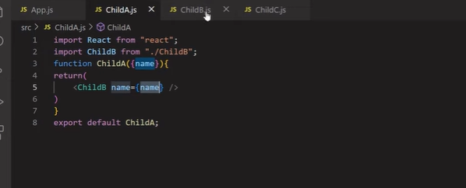

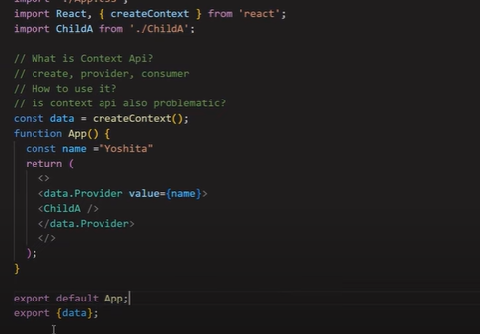

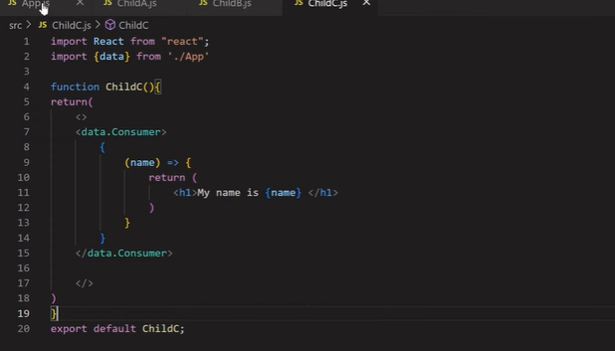

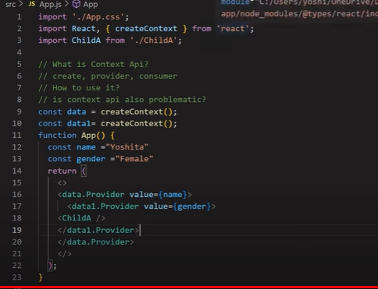

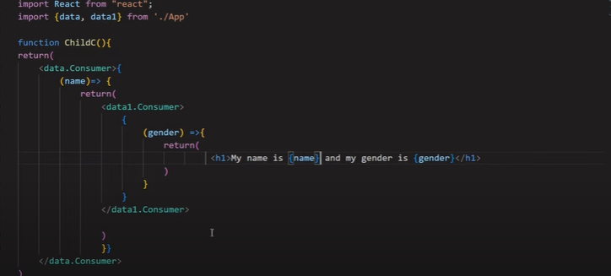

ue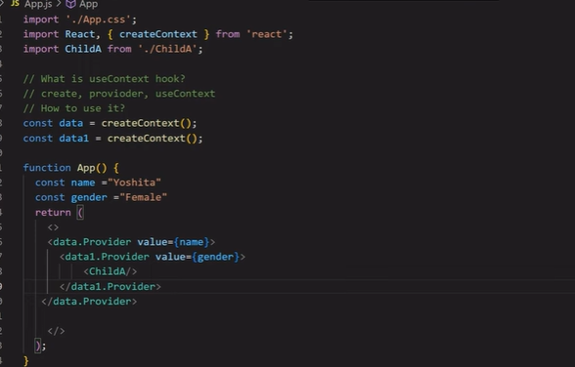

useref

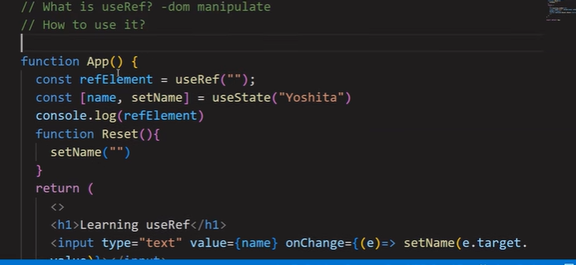

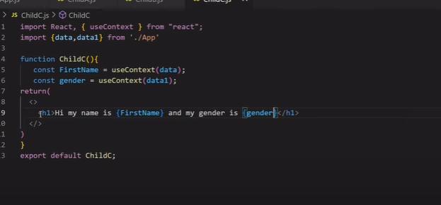

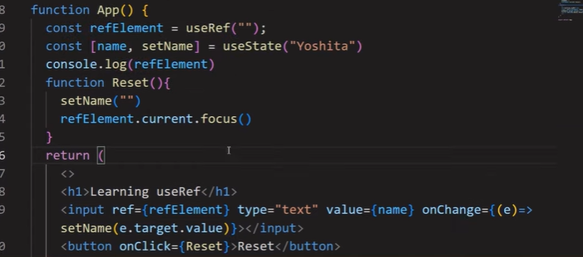

1. Explain usereducer

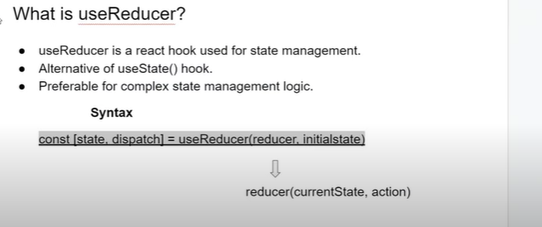

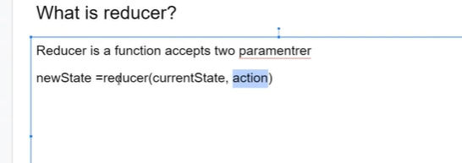

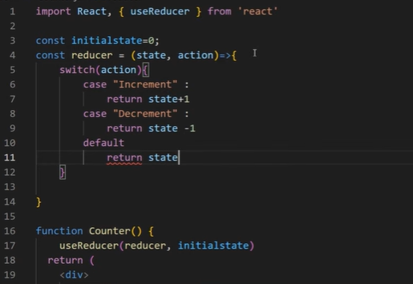

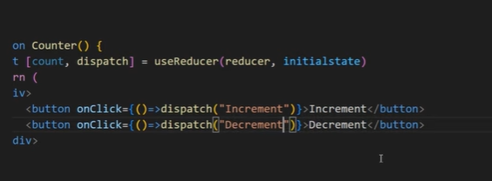

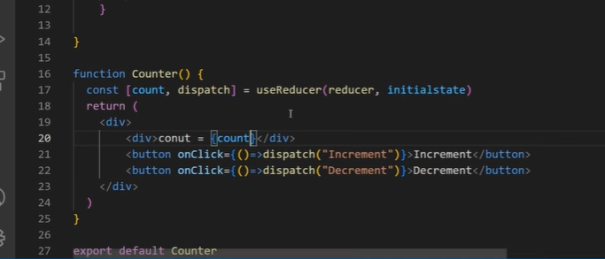

Custom hook

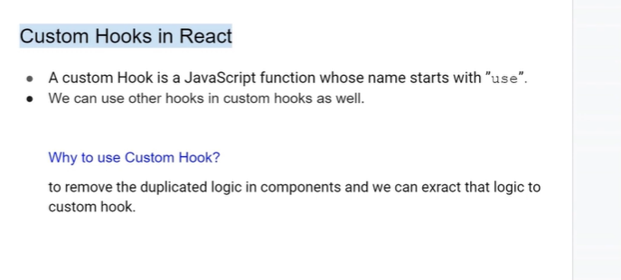

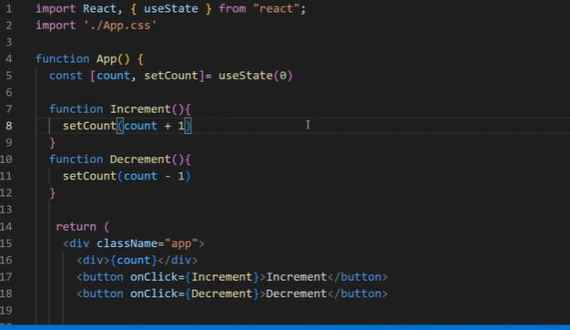

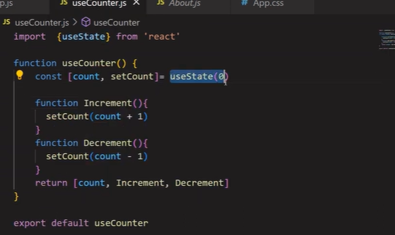

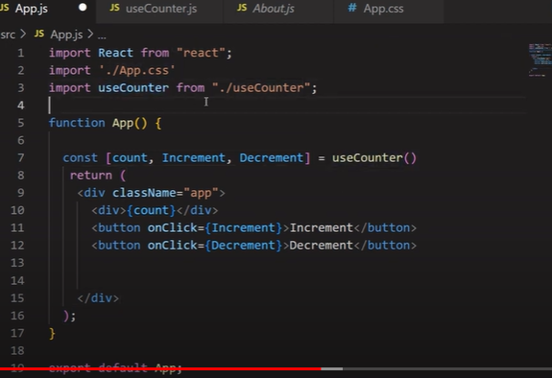

Post data thorogh fetch

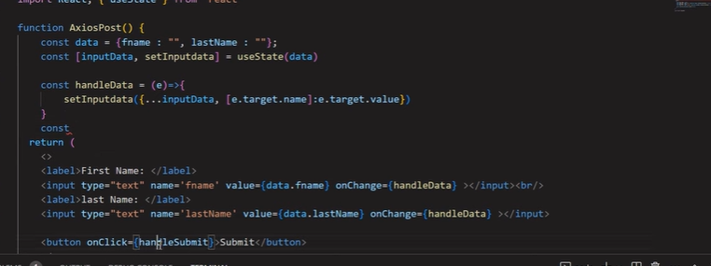

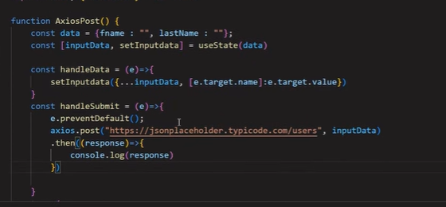

1. What is Redux why we use redux ?

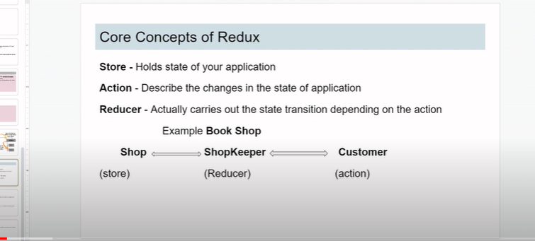

1. What is action reducer and dispatch
2. How to update state immutably.
3. What is action creator
4. What is redux thunk
5. How to create store
6. Tell me the redux flow
7. What is jsx in reactjs how it is deffer from html?
8. How do you embed js expression in JSX?
9. What is role of return statevment in jsx function
10. What is diff between jsx element and js fuction
11. What is react component and how does it differ from react element
12. What is role of render method in react component
13. Explain the purpose of state in react component
14. How to pass data from parent to child vice -versa

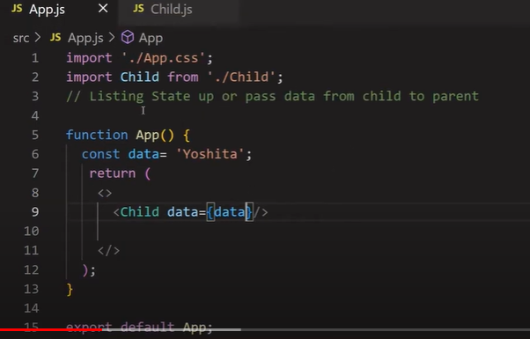

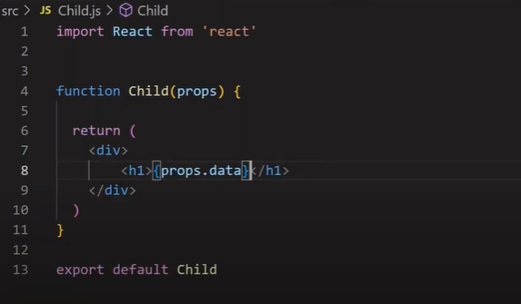

Chile to paranet

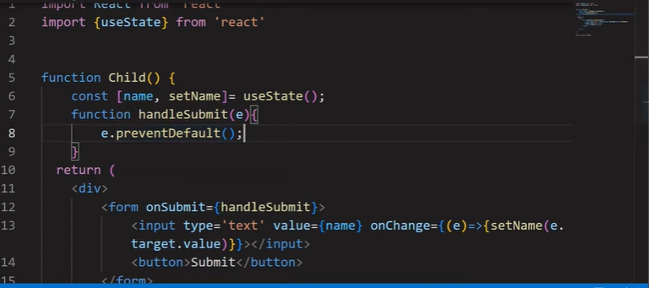

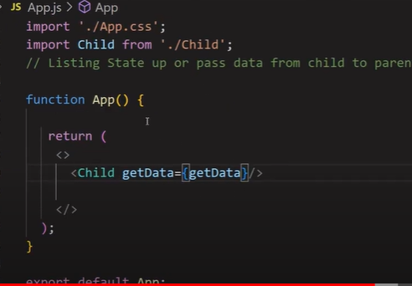

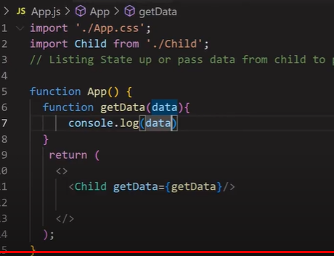

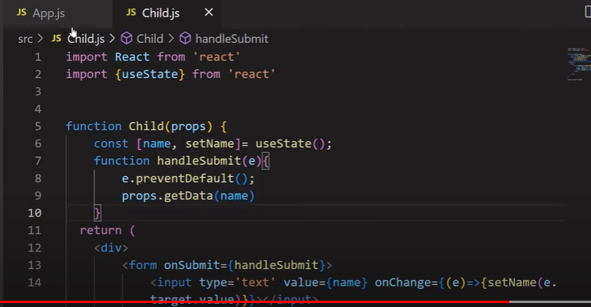

1. What is controlled and uncontrolled component
2. Difference between state and props in reactjs

• **Props:** Passed from parent to child and controlled by the parent component.

• **State:** Managed within the component and controlled by the component itself.

• **Props:** Immutable, cannot be modified by the receiving component.

• **State:** Mutable, can be updated using setState (class components) or useState (functional components).

• **Props:** Used to pass data and callbacks down the component tree.

• **State:** Used to manage data that changes over time within the component.

• **Props:** Facilitate communication from parent to child.

• **State:** Primarily used for

1. Who do you update state in react component
2. How to handle asynchronous state updates in reactjs?
3. What is the diff between stateful and stateless component
4. What is memorization how does it improve the performance

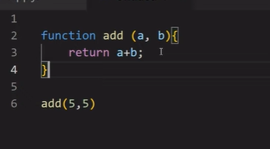

When we call same function with same parameter then it does not recalculate it see their catch already store the value it return it so that speed will increase and performance also increase

1. How do you use shouldcomponentupdate to optimize updates?
2. What is role of react.memo function

It contain the memorise value

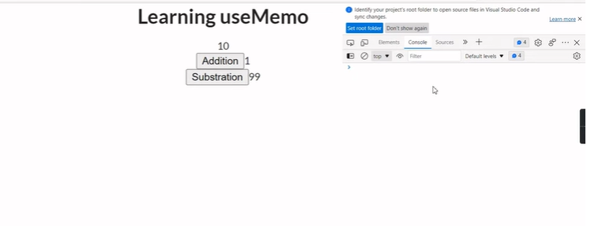

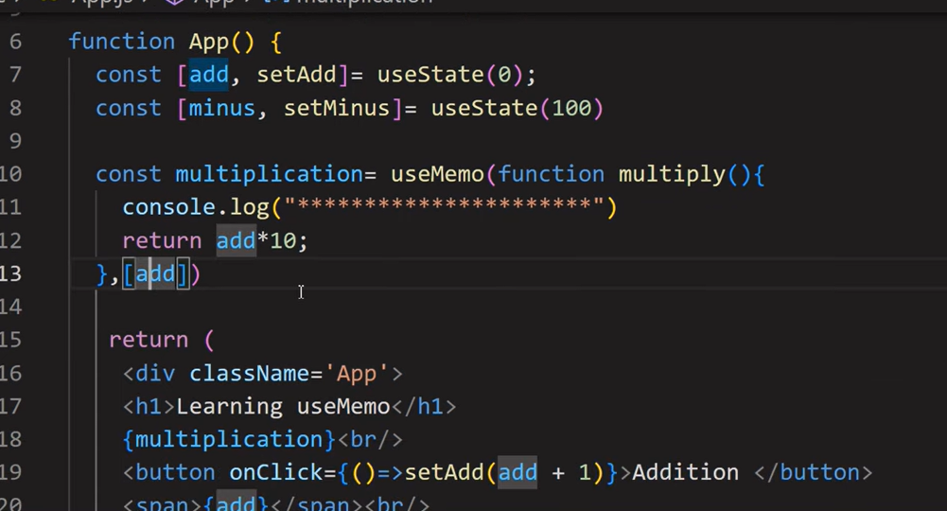

1. What is pure components

Reactjs web performance optimization

1. How you can optimize website performance
2. Explain lazy loading and its benefit

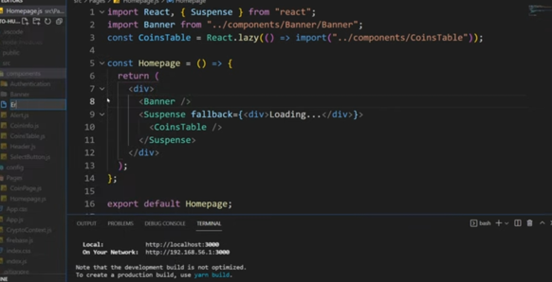

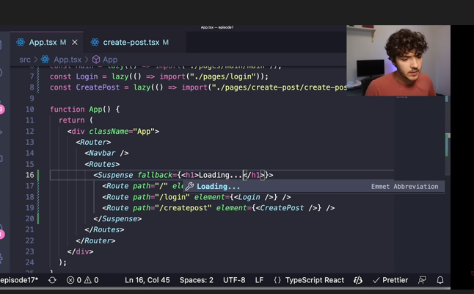

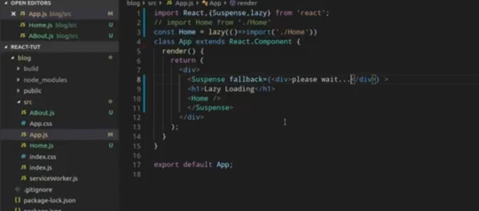

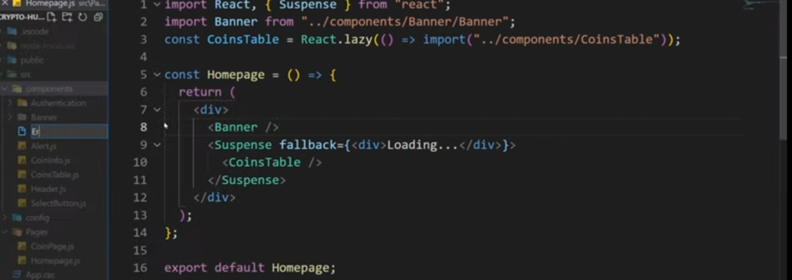

1. Explain code splitting
2. What is CORS and how does it work?
3. Describe how to handle cors issue in web application
4. Describe all basic git commands
5. Ho w to handle the error and debugging in reactjs?
6. What is role of keys props in lists
7. How to we handle the accessebiltity in React
8. What is diff between presesntaional and container component

**Build tool**

1. What is webpack and how does it improve the frontend development workflow?
2. Explain the concept of code splitting

**Testing in frontend Development**

Jest is a popular testing framework for JavaScript applications, often used with React due to its ease of integration and powerful features. It was developed by Facebook and is well-suited for testing React components, including features like mocking, snapshot testing, and coverage reporting.

**Features of Jest**

* **Zero configuration**: Works out of the box with most JavaScript projects.
* **Snapshots**: Easily capture and compare snapshots of React components.
* **Mocks**: Simplifies creating mock functions and modules.
* **Asynchronous Testing**: Handles async code with ease.
* **Built-in Code Coverage**: Generates code coverage reports.

1. **What are the benefit of unit testing in a** frontend application
2. **Describe the diff/ between unit and integration testing**

Javascript question

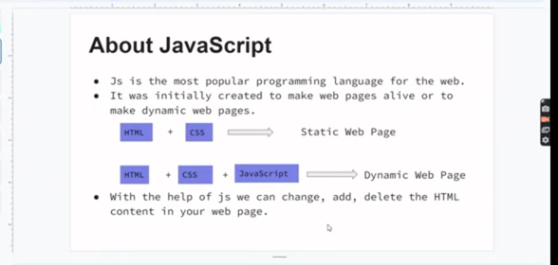

1. What are the feature of ES6
2. What is arrow function
3. What is default parameter ? can we use default parameter for first parameter in function?
4. What is destructuring
5. What is Prototype inheritance in javascript

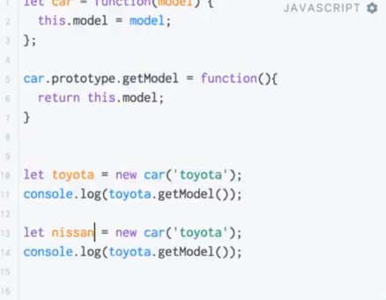

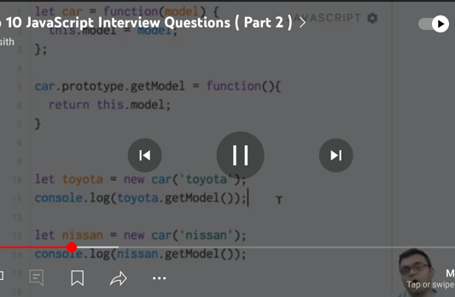

1. What is closure?



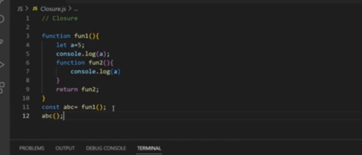

1. Advantage and disadvantage of closure

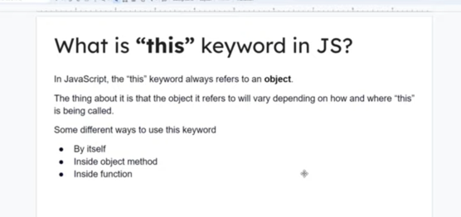

1. What is promise?

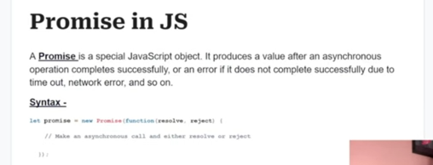

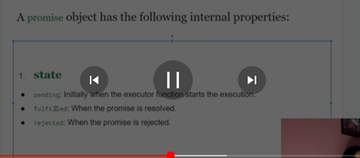



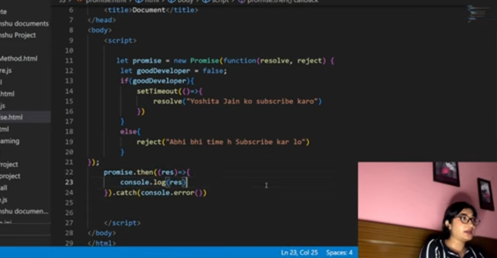

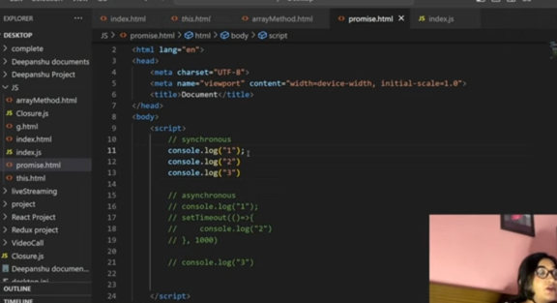

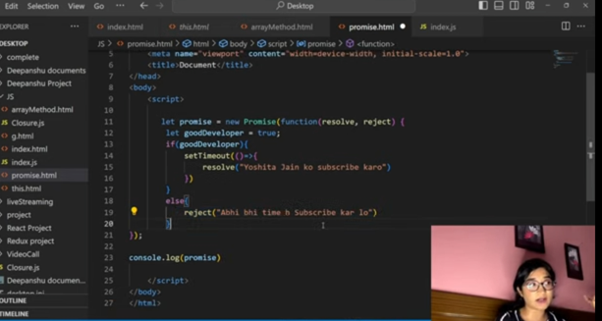

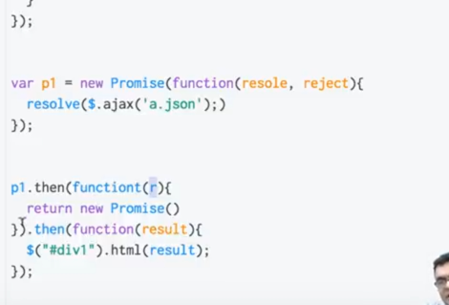

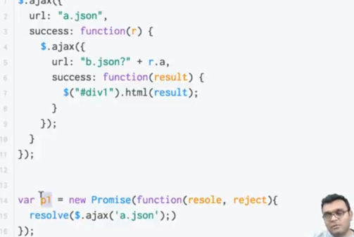

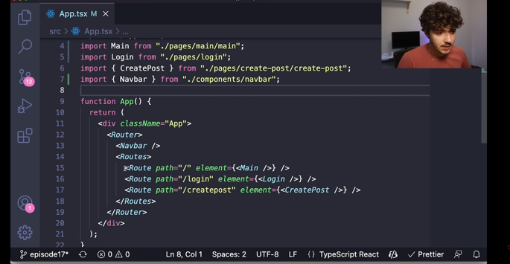

1. How to write own promise
2. What is hoisting?

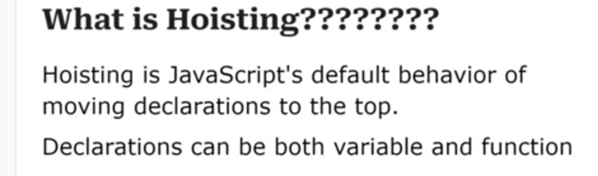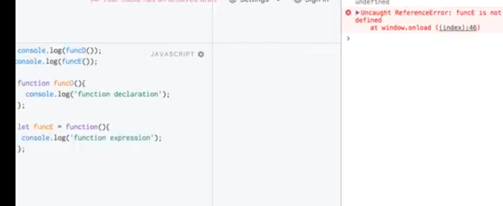

1. What is obeject destructuring?
2. If we merge object using spred operator what will be the output
3. If two object having same property in both object can we merge using spred oprator ? what will be the output?
4. What is reduce mehod in js
5. Data type in js
6. Type of null ,Nan,undefined and object
7. What is async await
8. Foreach vs map method in js

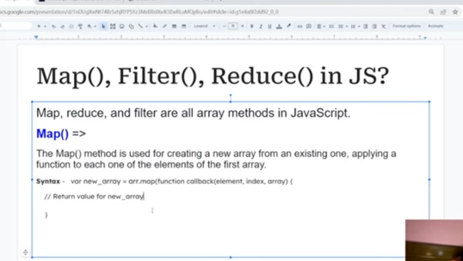

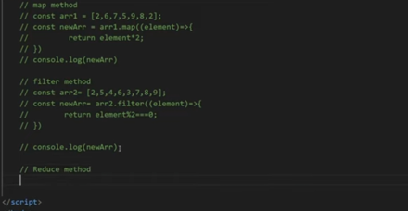

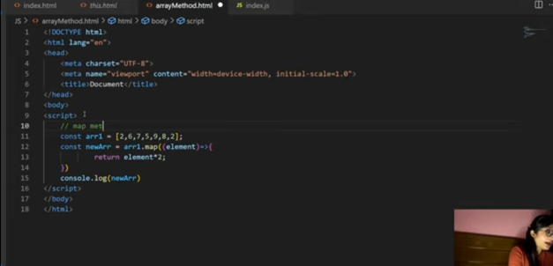

1. What is callback function in js
2. What is call(),apply() and bind() method

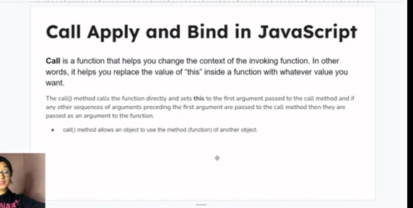

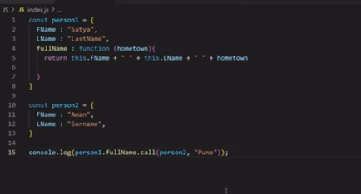

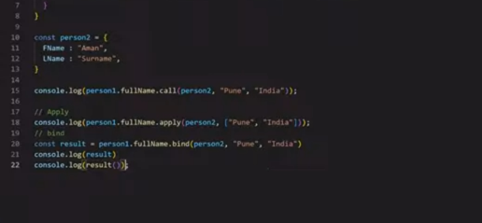

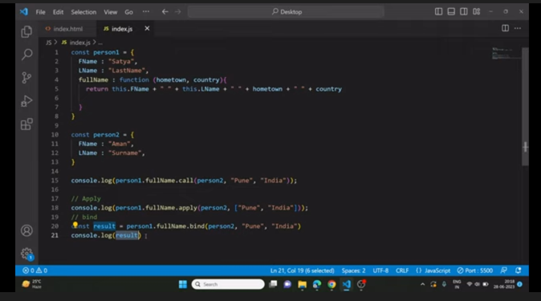

1. Difff between “==” and “===” operator
2. What is immediately invoke function in js
3. Diff between Let, const and VAR

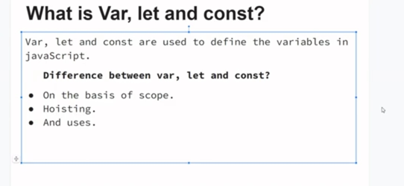

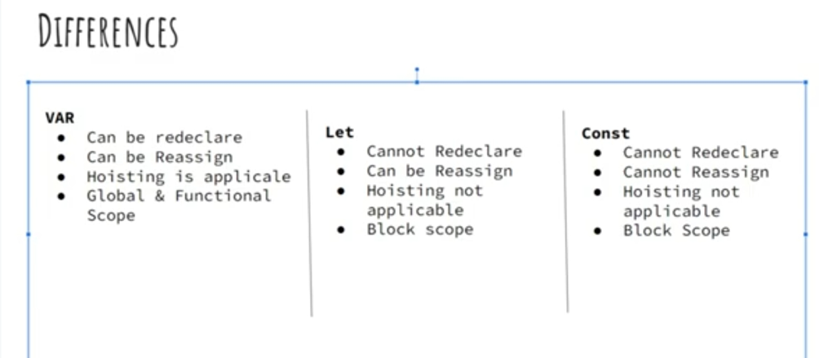

1. What is rest and spread parameter
2. What is classes in js
3. What is currying in js
4. Hof in js
5. What is event bubbling and event capturing in js

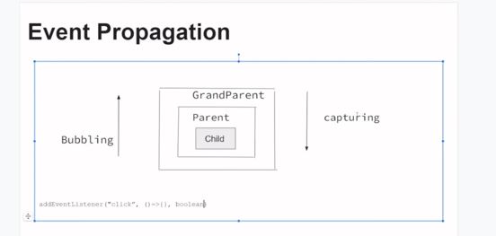

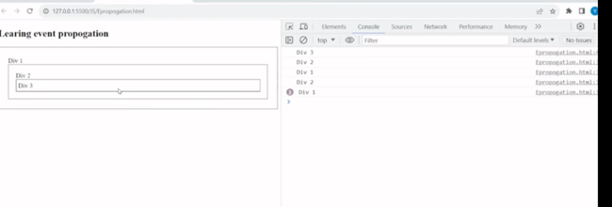

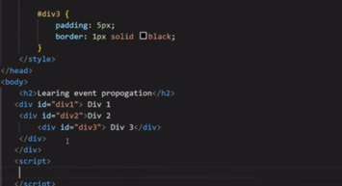

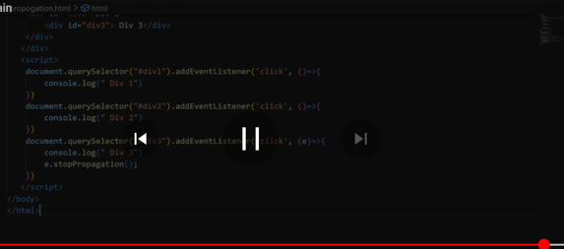

1. What is diffrenec between undefined value and null value
2. What is falsy value in javascript
3. Explain the event loop
4. What is use of shallow and deep copy

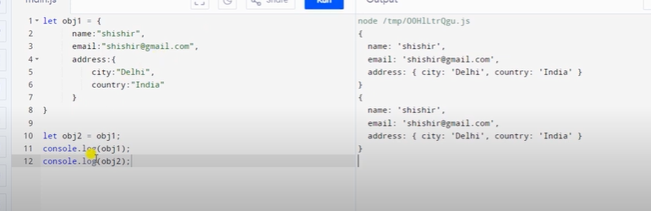

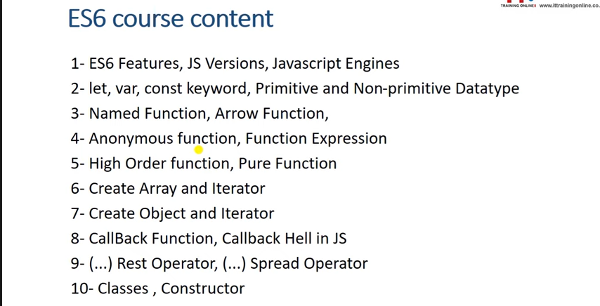

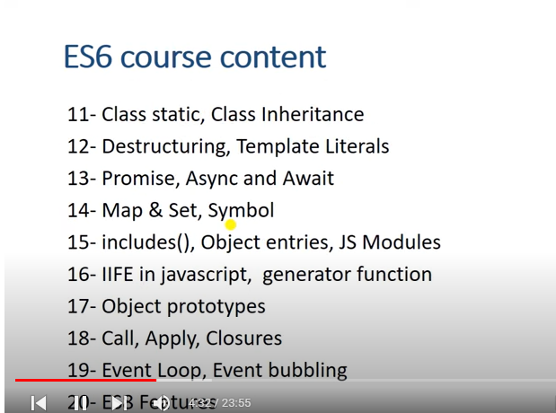

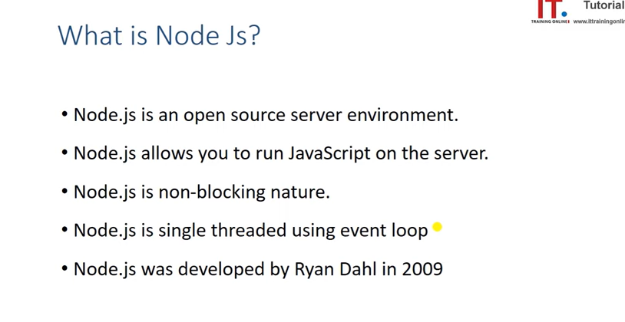

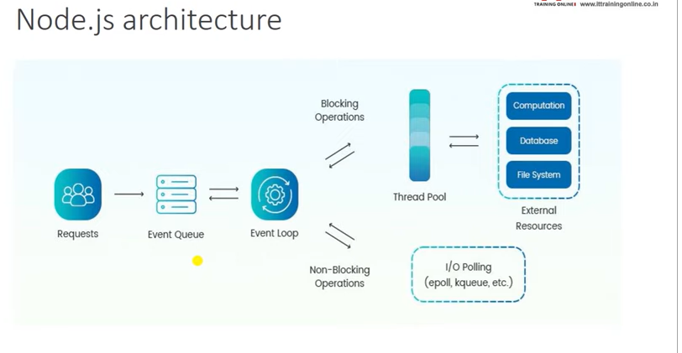

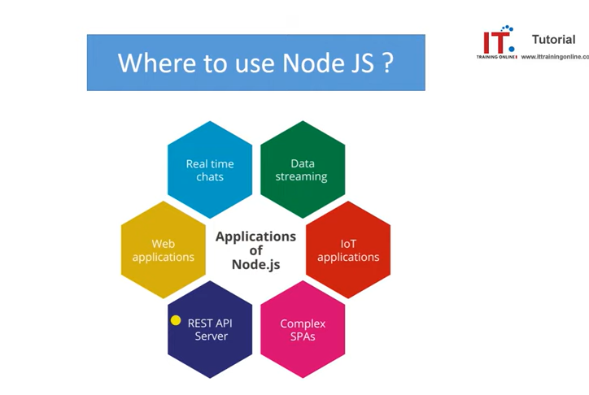

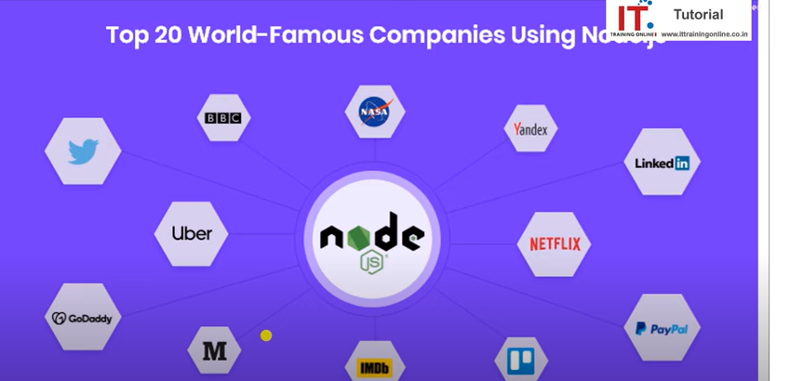

<https://www.youtube.com/watch?v=3d-leGuuva4&list=PLoo9_ntqDMDCtaFIYfvdFOyEs4oSk6jUz&index=2>

logical question-

const menuItems = [

{

menu: "home",

link: "https://www.programiz.com/javascript/online-compiler/",

subitems: [

{

menu: "about",

link: "https://www.programiz.com/javascript/online-compiler/"

}

]

}

];

// Function to extract menu values from the menuItems array

function extractMenuValues(items) {

let menuValues = [];

items.forEach(item => {

menuValues.push(item.menu);

if (item.subitems && item.subitems.length > 0) {

item.subitems.forEach(subitem => {

menuValues.push(subitem.menu);

});

}

});

return menuValues;

}

const menuValues = extractMenuValues(menuItems);

console.log(menuValues); // Output: ["home", "about"]

const arr = [

{ name: 'apple', category: 'fruit' },

{ name: 'apple', category: 'fruit' },

{ name: 'onion', category: 'veg' },

{ name: 'pumkin', category: 'veg' }

];

const op = arr.reduce((accu, element) => {

const cat = element.category;

if (!accu[cat]) {

accu[cat] = [];

}

accu[cat].push(element.name);

return accu;

}, {});

console.log(op);

const arr = [1, 6, 8, 5, 6, 1];

const occurrences = arr.reduce((accu, element) => {

// If the element already exists in the accumulator, increment its count

if (accu[element]) {

accu[element]++;

} else {

// Otherwise, initialize the count to 1

accu[element] = 1;

}

return accu;

}, {});

console.log(occurrences);

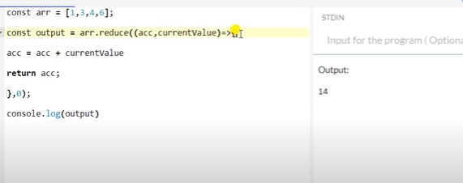

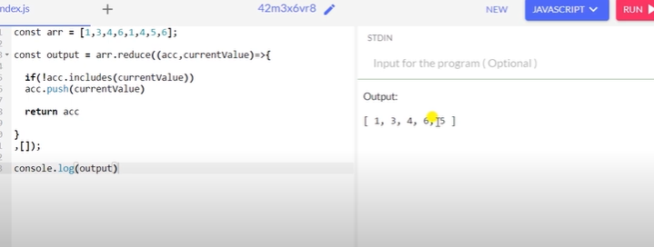

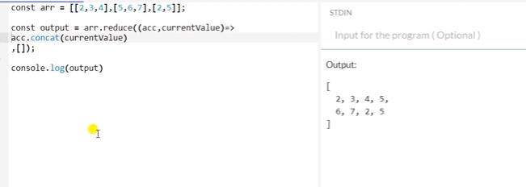

Regular and arrow function –

